Assignment day 7

Kurtosis value for percentage salay hike is -0.3026

Which suggests percentage hike is a factor to be considered.

The Mean of MonthlyIncome is at 65029 suggesting company wide Attrition.

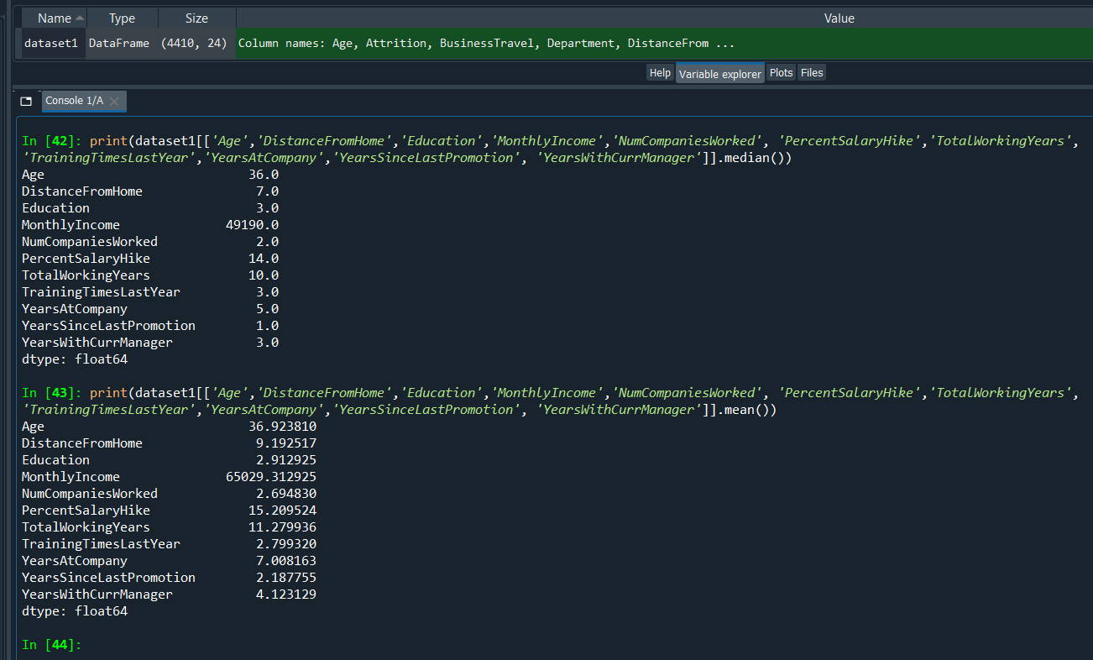

Monthly Income is right skewed with many outliers

